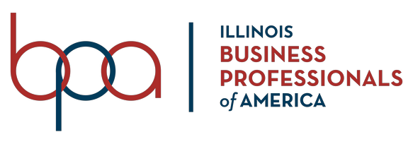

September 23, 2020

Dear Fellow Business Professionals

Business Professionals of America Illinois Association invites you to attend this year’s Fall Leadership Conference. The Fall Leadership Conference will be held virtually on Friday, November 13th, 2020 at 12:30 p.m..

The State Officer Team really looking forward to welcoming all of our members of Business Professionals of America Illinois Association and eagerly waiting to hear from the 2020-2021 state officer candidates. The newly elected officer team will dedicate their hard work and time towards serving our organization and its members. Good luck to all candidates.

In addition to the election, we will have the pleasure of having a Gold Medal winner for the USA Track & Field Team, 3-time NCAA All-American, and entrepreneur, Mr. Eddie Slowikowski as our motivational speaker for the day. Furthermore, Mr. Slowikowski will be running a leadership workshop for all who attend.

On behalf of the entire State Officer Team, we hope you Envision, Empower, and Ignite a new chapter in your Business Professionals of America journey by attending the Fall Leadership Conference. We look forward to seeing you all there!

Best regards
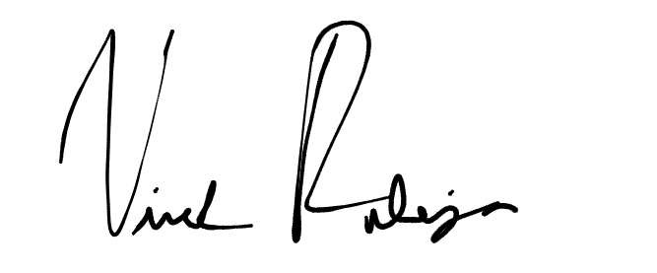
Vivek Raheja
State President

